About the University of Plovdiv “Paisii Hilendarski”:
Plovdiv University is one of the leading higher-education institutions in the Republic of Bulgaria, with teaching facilities, situated in three cities (Plovdiv, Smolyan and Kardzhali). Also known as the University of Paisii Hilendarski, it is the largest university in southern Bulgaria and as well the second biggest in Bulgaria. The university was initially founded in 1961 as a Higher Institute of Pedagogy for Natural Sciences and Mathematics; however, it was awarded university status in 1972. Today Plovdiv University provides degree-level education to students in more than 60 disciplines encompassing the humanities, social sciences and the aforesaid subjects. 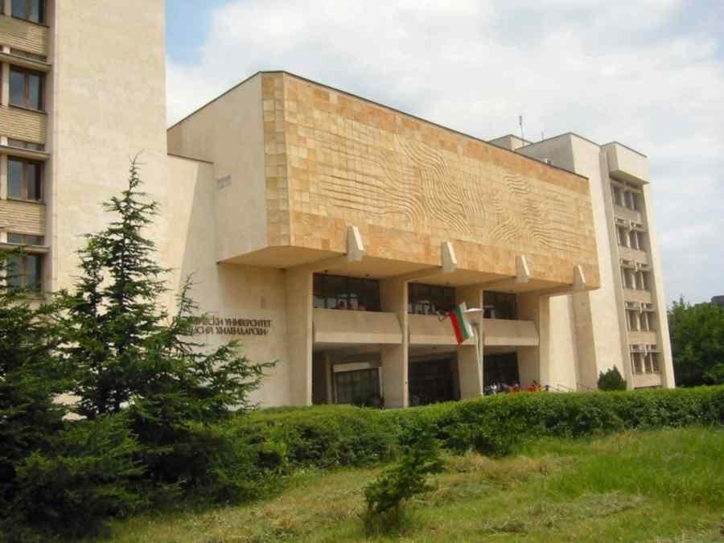
Plovdiv University employs over 900 academic and non-academic members of staff. There are 550 full-time academic employees, of whom 30 are Full Professors, 160 Associate Professors and 360 Lecturers. More than 13,000 full-time students and approximately 5,300 part-time students study in the nine faculties of the University. The University of Plovdiv prides itself on being a fully regulated institution that accepts students and hires and indeed promotes staff in full compliance with the Law of Higher Education. The University has received official state accreditation, which allows it to confer each form of educational degree i.e. specialist, bachelor, master and doctor.
About the Faculty of Mathematics and Informatics
The Faculty of Mathematics and Informatics (FMI) dates back to 1961 when it became the first standalone faculty at University of Plovdiv Paisii Hilendarski. Today, FMI is a well-established research and training centre by international standards and provides degree programs in the fields of Mathematics, Informatics and Information Technology. There are some 87 highly qualified members of the full-time academic staff, with 14 Full Professors and 28 Associate Professors, more than half have been awarded doctoral degrees - we have 5 Doctors of Science and 71 PHD holders. FMI has a Scientific Council entitled to conferring the academic rank of Associate Professor. 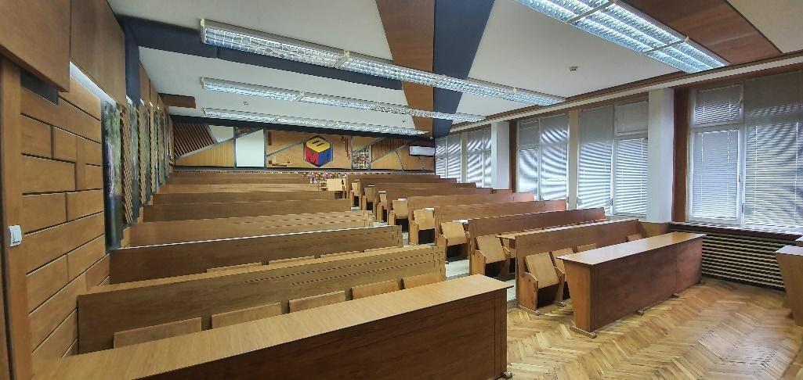

Every year, FMI trains more than 2,000 students pursuing Bachelor's or Master's degrees in various specialties under the professional streams of Mathematics, Informatics and Computer Science, and Pedagogy of Teaching. The most attractive bachelor programs are Software Engineering, Software technologies and design, Computer Science and Business Information Technologies. FMI also offers doctoral training programs and postgraduate training programs. 

About Plovdiv:
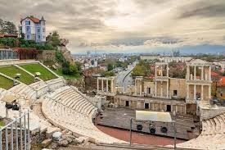
Plovdiv is the second-largest city in Bulgaria after Sofia, with a city population of 346,893 and 675,000 in the greater metropolitan area. Plovdiv is the culture capital of Bulgaria. It is an important economic, transport, cultural, and educational center. There is evidence of habitation in Plovdiv dating back to the 6th millennium BC, when the first Neolithic settlements were established. It has been considered to be one of the oldest alive cities in the world.
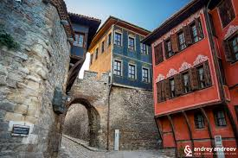
A contemporary of Troy, Plovdiv is a city upon layers of cities and an epoch upon layers of epochs. Plovdiv is all in one: a Thracian and classical Greek polis, the pride of Philip of Macedon, the capital of Thrace under the Roman Empire, a centre of Byzantinism, a stronghold of the Bulgarians and a dream of the crusaders.
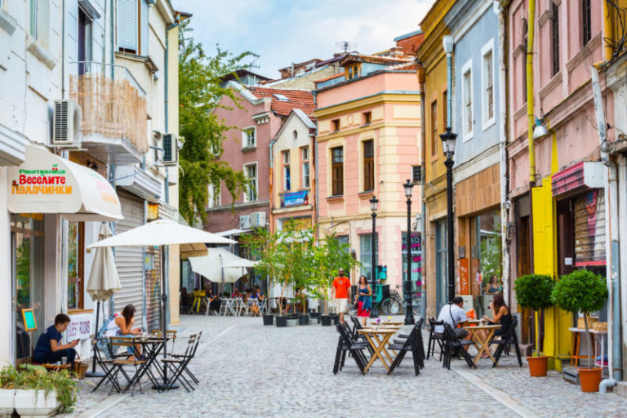
Plovdiv is a Bulgarian capital of culture and it was also a European Capital of culture in 2019. Culture lovers can enjoy magnificent presentations with unique Bulgarian folk music and dances; opera performances, sitting in authentic Roman amphitheater; watching the craftsmen in their workshops, placed in 19 century picturesque part of the city; visiting museums and galleries; etc.

